# **Assignment: 04**

## **Step 1: Open Remix IDE and create a solidity contract by name Bank.sol and use this below code**

// SPDX-License-Identifier: MIT

pragma solidity ^0.8.17;

contract Bank{

    address public accOwner;

    constructor() {

        accOwner = msg.sender;

    }

    // Deposit money into the contract

    function depositMoney() public payable {}

    // Withdraw money from the contract

    function withdrawMoney(uint256 ammount) public payable  {

        require(accOwner==msg.sender, "You are not the account owner");

        require(ammount > 0, "Ammount must be greater than zero");

        payable(msg.sender).transfer(ammount);

    }

    function transferMoney(address payable recipient, uint256 ammount) public{

        require(accOwner==msg.sender, "You are not the account owner");

        require(ammount > 0, "Ammount must be greater than zero");

        recipient.transfer(ammount);

    }

    function showBalance() public view returns (uint256) {

        return address(this).balance;

    }

}

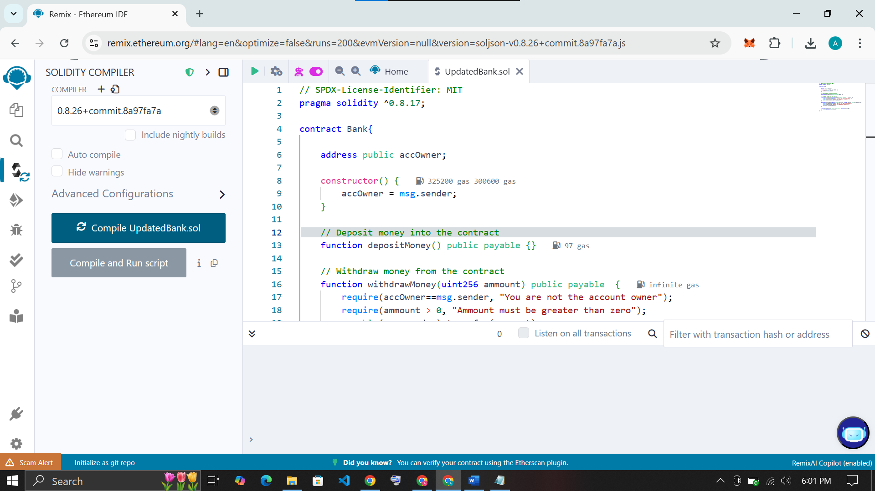

## **Step 2: Compile the .sol file**

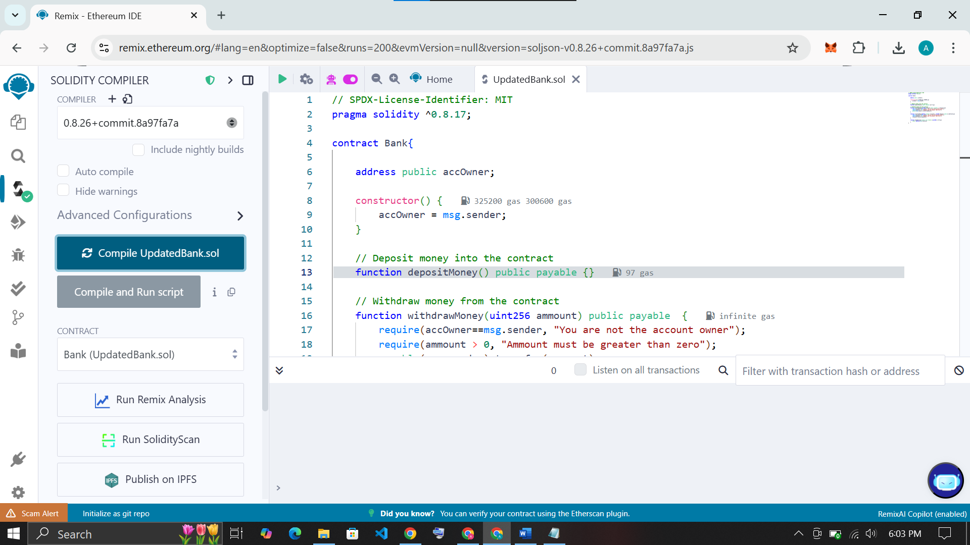

## **Step 3: Deploy the contract**

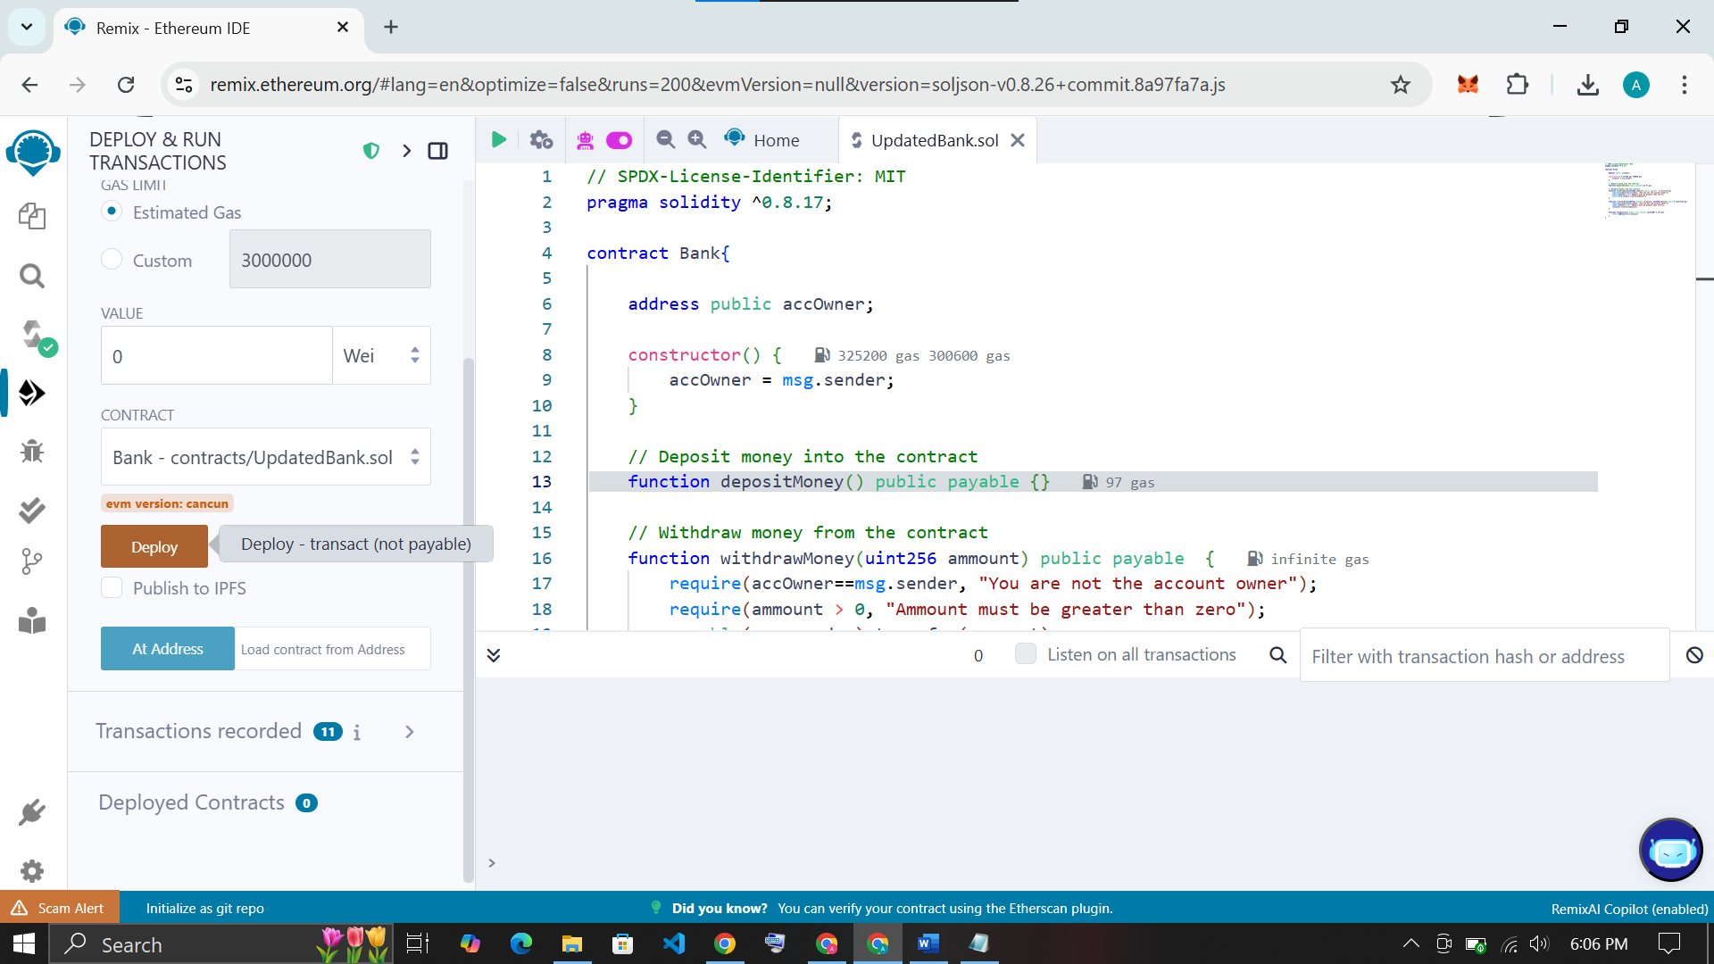

## **Step 4: Interact with the contract**

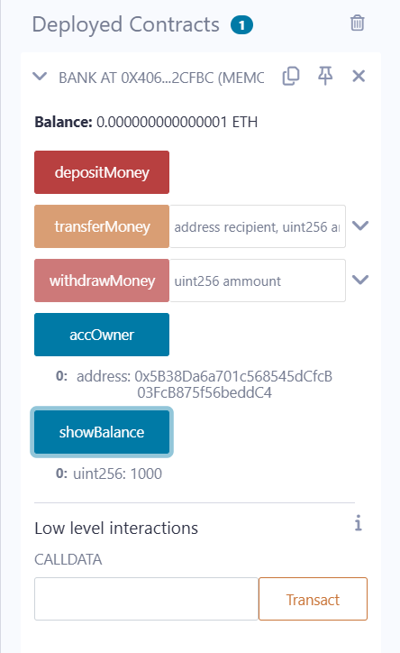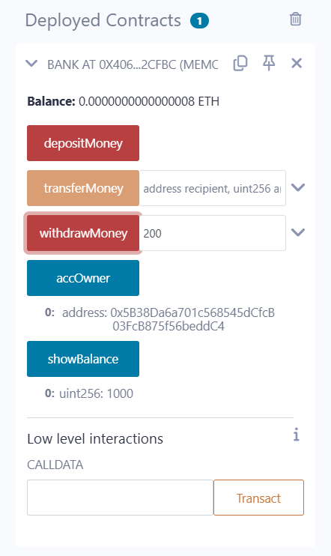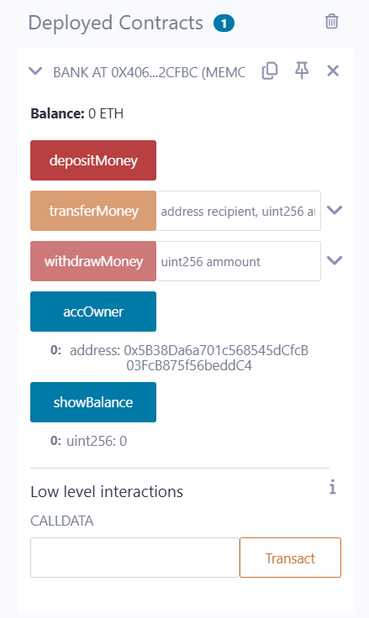

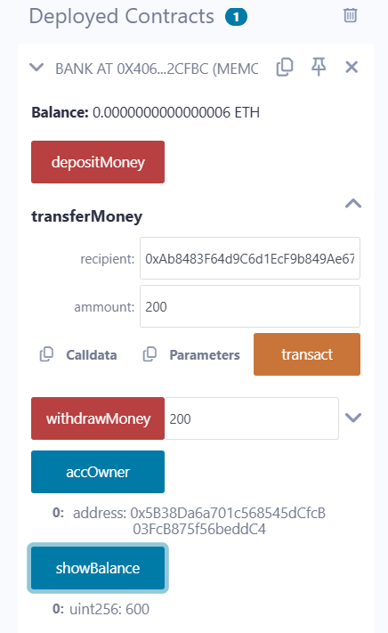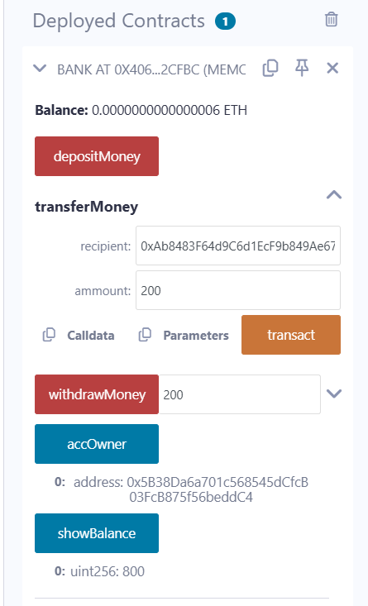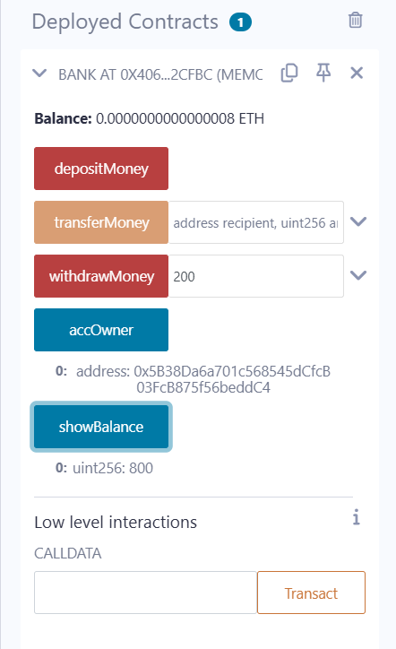

Sender / accOwner address : 0x5B38Da6a701c568545dCfcB03FcB875f56beddC4

Receiver address:

0x406AB5033423Dcb6391Ac9eEEad73294FA82Cfbc

Balance = 800 Wei

Balance = 800 – amount

Balance = 600 Wei in Owners account

## **This is the transaction log from terminal**

|  |  |
| --- | --- |
| **status** | 0x1 Transaction mined and execution succeed |
| **transaction hash** | 0x5e5cc611ae7ae440487881a0e7f9539df4ccfc6dcfe2b76b8950ec9ab6a7606a |
| **block hash** | 0xe07dd6a9f65a3cb61c9423c69af5edda494068fd3c1ae9d65bcaa2b49998b7ad |
| **block number** | 56 |
| **from** | 0x5B38Da6a701c568545dCfcB03FcB875f56beddC4 |
| **to** | Bank.transferMoney(address,uint256) 0x406AB5033423Dcb6391Ac9eEEad73294FA82Cfbc |
| **gas** | 38927 gas |
| **transaction cost** | 33849 gas |
| **execution cost** | 12277 gas |
| **input** | 0xfee...000c8 |
| **output** | 0x |
| **decoded input** | { "address recipient": "0xAb8483F64d9C6d1EcF9b849Ae677dD3315835cb2", "uint256 ammount": "200" } |
| **decoded output** | {} |
| **logs** | [] |
| **raw logs** | [] |